[](http://www.authoritysportsuk.co.uk)

[**AuthoritySportsUK**](http://www.authoritysportsuk.co.uk)

**Gymnastics**

**Functional**

**Index**

2022/2023

AGFI

Toolkit for accurately measuring and recording outcomes in

**Disability Gymnastics**

**For use with Winstrada Gymnastics Primer Awards.**

[](http://www.gymnasticbritannia.org)

Author:

Paul Hurd

[](https://www.winstrada.com/ukdist.php?origin=authority)AuthoritySportsUK Gymnastics Function Index based on the

Huddersfield Function Index (HFI) © Rebound Therapy.

Compiled with full support from Rebound Therapy & Paul V Kaye.

© 2022 Authoritysportsuk.co.uk, Winstrada, Paul Hurd and Paul V Kaye.

All rights reserved. The owner of this manual has permission to copy relevant sections for personal use.

Not to be reproduced in whole or for commercial purposes without the permission of the copyright owners.

The course organiser will have given you the code and login instructions to enable you to access the reading material for the Disability Gymnastics course.

If for any reason you have not received this information, you can ccess the reading material the following wa:

1. Go to www.
2. Click login area
3. Enter the code ********8 in the box and click login
4. Click on ‘Disability Gymnastics Course Reading Material’

**It is necessary for all candidates to read all the course information**

If you have not yet had time to read all the information, the following papers are essential reading before completion of your course.

Risk Assessments, Benefits, Contra-indications, Development and Award Scheme

**Acknowledgements:**

The author and publishers would like to thank the following for their invaluable contributions in the production of this work:

Richard Watterston for the original concept of the Huddersfield Functional Index from which this is based.

Paul V Kaye, for the updated concept of the HFI for which this is based, also parts of this pack, which have been copied directly with permission from Paul V Kaye and Rebound Therapy.

### Additional hard copies of this manual are available by contacting AuthoritySportsUK office email: **authoritysportuk@gmx.co.uk**

Published by AuthoritySportsUK.co.uk,

5 Chesley Farm, Bull Lane, Newington, Sittingbourne, Kent, ME9 7SJ

Web: [www.authoritysportsuk.co.uk](http://www.authoritysportsuk.co.uk)

**Benefits of Gymnastics: Essential Reading Material**

Benefits of Gymnastics: [Australian Gymnastics Click for Article](https://www.gymnastics.org.au/VIC/Posts/News_Articles/2018/July/Benefits_of_Gymnastics_.aspx)

11 Health Benefits according to Science Document: [STK Sport Click Here](https://www.stk-sport.co.uk/gymnastics-science-health-benefits-of-gymnastics.html#:~:text=It%20helps%20build%20self%2Dmorale,total%2Dbody%20strength%20and%20flexibility.)

Physical Therapy Gymnastics and People with Disabilities [Click Here](https://www.disabled-world.com/fitness/exercise/gymnastics.php)

Flaghouse Sensory Channel Benefits of Gymnastics YouTube part 1 [Click Here](https://www.youtube.com/watch?v=8-yKxMmlHmI)

Flaghouse Sensory Channel Benefits of Gymnastics YouTube Part 2 [Click Here](https://www.youtube.com/watch?v=xG81ce8KEBg)

Flaghouse Sensory Channel Sensory for limited space YouTube [Click Here](https://www.youtube.com/watch?v=3LhZ9K0pl30)

Understanding the benefits of gymnastics for children with a disability Research doc [Click Here](https://citeseerx.ist.psu.edu/viewdoc/download?doi=10.1.1.694.7366&rep=rep1&type=pdf)

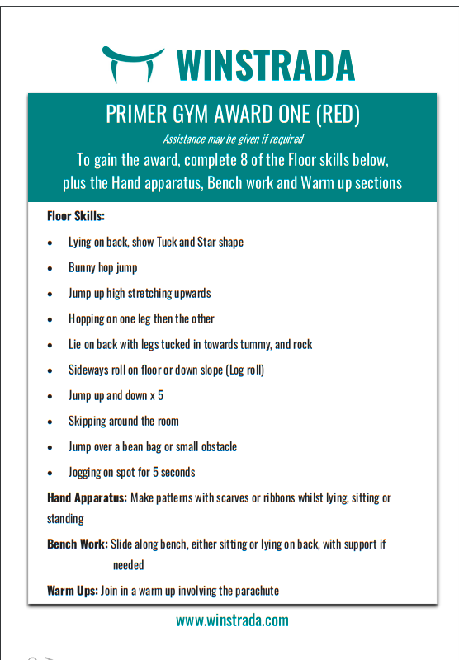

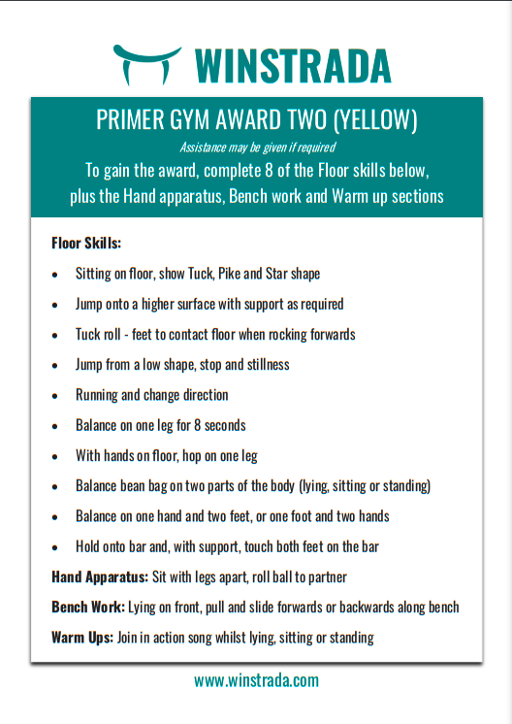

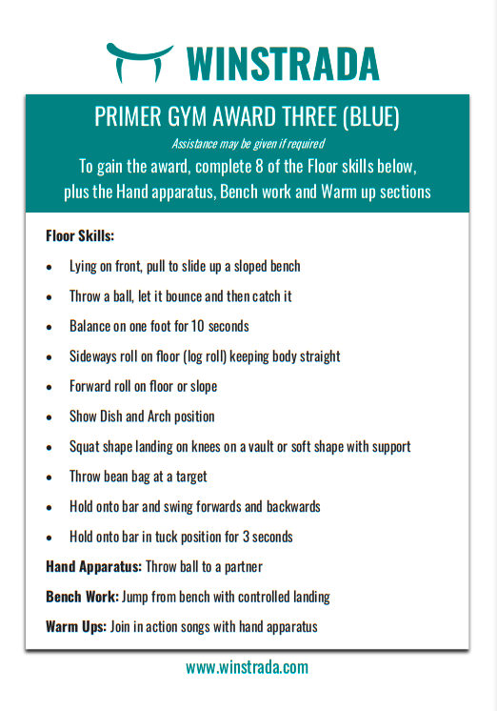

AGFI

Name......................................................................D.O.B......................................

Diagnosis................................................................................................................

Grade................... Commenced..............................................................................

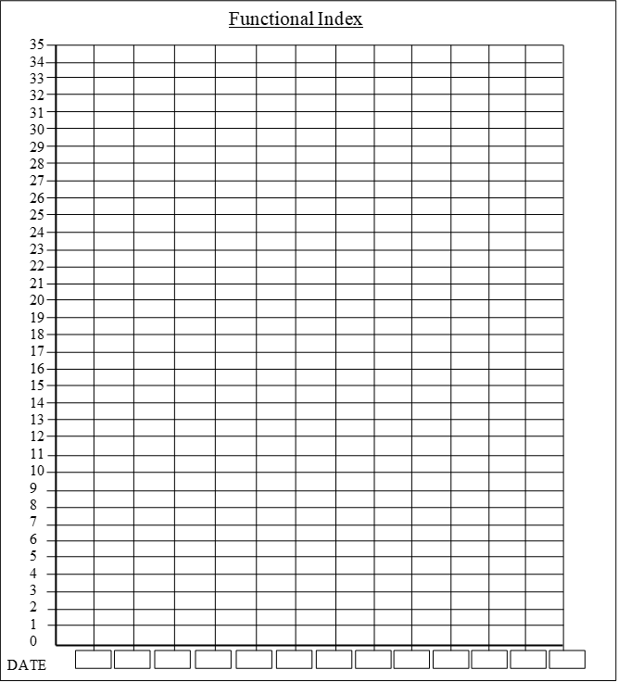

AGFI

Name......................................................................D.O.B......................................

Diagnosis................................................................................................................

Grade................... Commenced..............................................................................

B 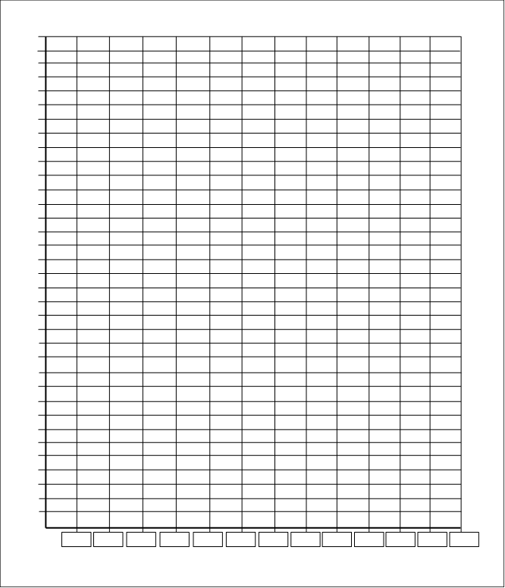

71

70

69

68

67

66

65

64

63

62

61

60

59

58

57

56

55

54

53

52

51

50

49

48

47

46

45

44

43

42

41

40

39

38

37

36